 | NATIONAL UNIVERSITY  OF COMPUTER & EMERGING SCIENCES  PESHAWAR CAMPUS | 

Student Name: Muhammad usman Roll No: P190096 Sec: 5B

Problem Set : Implement 01 Semester: FALL 2021
Date Set : Monday December 20, 2021 Due Date : Friday Dec.24, 2021
Course : CS301 Theory of Automata Instructor: Shakir

Language { a^i : i is a prime number}

Descriptive Definition:
Any number of a’s where length is equal to prime number.

Words:
{aa, aaa, aaaaa , aaaaaaa, aaaaaaaaaaa,aaaaaaaaaaaaa, aaaaaaaaaaaaaaaaa, aaaaaaaaaaaaaaaaaaa,
aaaaaaaaaaaaaaaaaaaaaaa , aaaaaaaaaaaaaaaaaaaaaaaaaaaaa ,

Turing Machine:
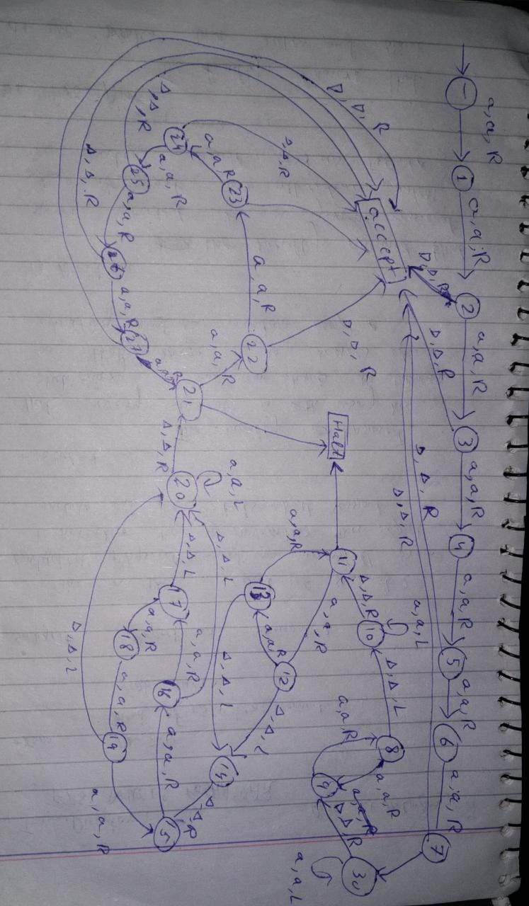

Code:
atimes = int (input("Enter length of a's : "))
string=""
while(atimes>0):
string=string+'a'
atimes=atimes-1

length = len(string) + 2

tape = ['B','B']*length
i = 1
tapehead = 1
for s in string: #loop to place string in tape
tape[i] = s
i += 1

state = 0
#assigning characters to variable so that don't have to use characters each time
X, Y, S, B, R, L = 'a', '*', '+', 'B', 'R', 'L'
oldtapehead = -1
accept = False

def action(input_char, replace_with, move, new_state):
global tapehead, state
if tape[tapehead] == input_char:
tape[tapehead] = replace_with
state = new_state
if move == 'L':
tapehead -= 1
return True
elif move == 'R':
tapehead += 1
return True
return False

while(oldtapehead != tapehead): #if tapehead not moving that means terminate Turing machine
oldtapehead = tapehead
print(tape , "with tapehead at index", tapehead, "on state" , state)

if state == 0:
if action(X, X, R, 1) :
pass

elif state == 1:
if action(X, X, R, 2) :
pass

elif state == 2:
if action('a', 'a', R, 3) or action(B,B,R,29) :
pass

elif state == 3:
if action('a', 'a', R, 4) or action(B,B,R,29) :
pass

elif state == 4:
if action(X, X, R, 5) :
pass

elif state == 5:
if action(X, X,R,6) or action(B,B,R,29) :
pass

elif state == 6:
if action(X, X,R,7) :
pass

elif state == 7:
if action(X ,X, R, 30) or action(B,B,R,29) :
pass

elif state == 8:
if action(X, X, R, 9) or action(B, B, L, 10) :
pass
elif state == 9:
if action(X, X, R, 8) :
pass
elif state == 10:
if action(X, X, L, 10) or action(B,B,R,11) :
pass
elif state == 11:
if action(X, X, R, 12) or action(B,B,L,28) :
pass
elif state == 12:
if action(X, X, R, 13) or action(B,B,L,14) :
pass

elif state == 13:
if action(X, X, R, 11) or action(B,B,L,14) :
pass
elif state == 14:
if action(X, X, L, 14) or action(B,B,R,15) :
pass
elif state == 15:
if action(X, X, R, 16) or action(B, B, L, 28) :
pass
elif state == 16:
if action(X, X, R, 17) or action(B, B, L, 20) :
pass
elif state == 17:
if action(X, X, R, 18) or action(B,B,L,20) :
pass
elif state == 18:
if action(X, X, R, 19) or action(B,B,L,20):
pass

elif state == 19:
if action(X, X, R, 15) or action(B,B,L,20) :
pass
elif state == 20:
if action(X, X, L, 20) or action(B,B,R,21) :
pass

elif state == 21:
if action(X, X, R, 22) or action(B,B,R,28) :
pass
elif state == 22:
if action(X, X, R, 23) or action(B,B,R,29) :
pass
elif state == 23:
if action(X, X, R, 24) or action(B,B,R,29) :
pass
elif state == 24:
if action(X, X, R, 25) or action(B,B,R,29) :
pass
elif state == 25:
if action(X, X, R, 26) or action(B,B,R,29) :
pass
elif state == 26:
if action(X, X, R, 27) or action(B,B,R,29) :
pass
elif state == 27:
if action(X, X, R, 29) :
pass

elif state == 30:
if action(X, X, L, 30) or action(B,B,R,9) :
pass

elif state == 28:
accept=False

elif state == 29:
accept=True

else:
accept = False

if accept:
print("String accepted on state = ", state)
else:
print("String not accepted on state = ", state)

